Azure Rebase

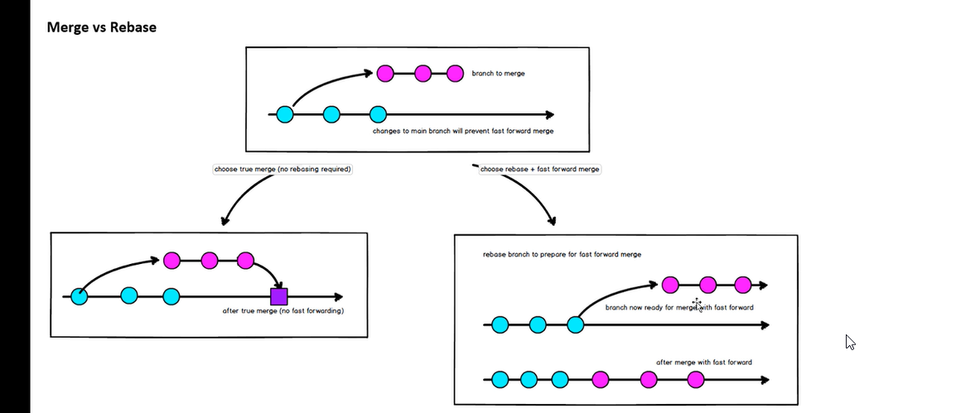

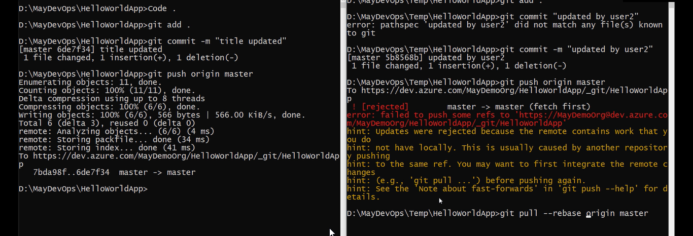

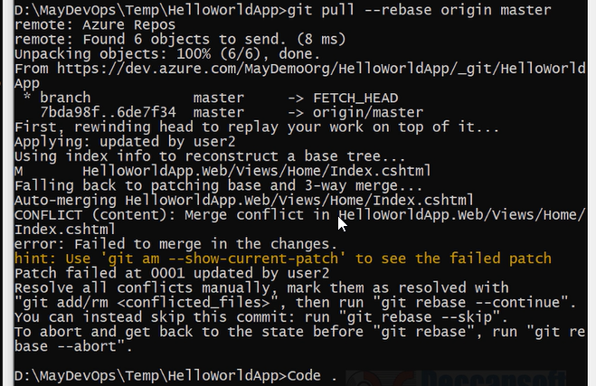

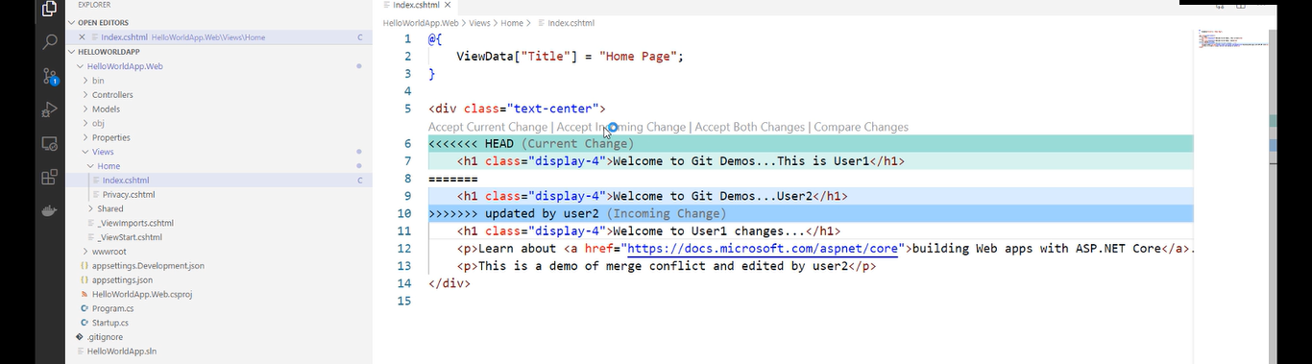

Accept incoming changes

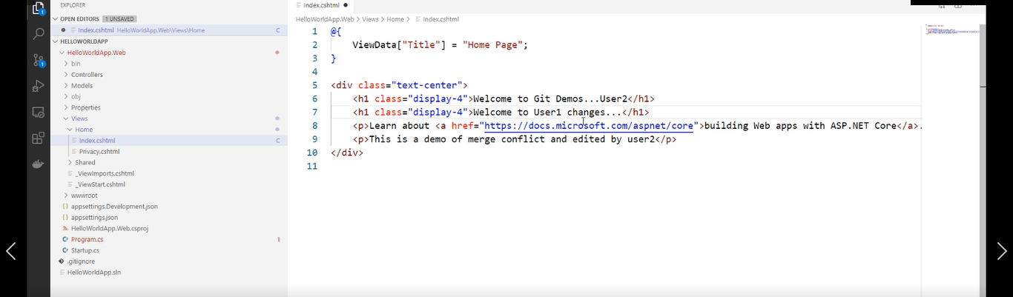

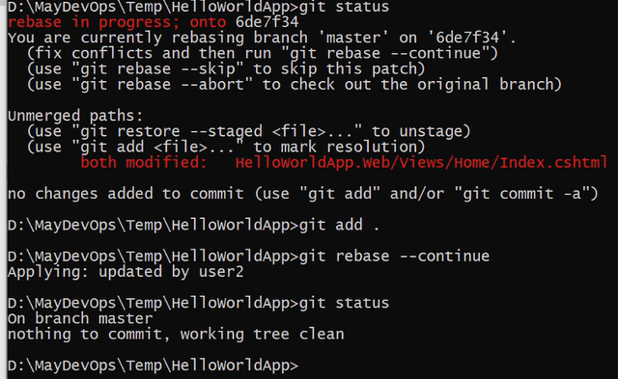

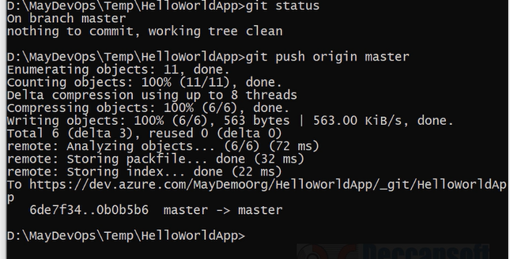

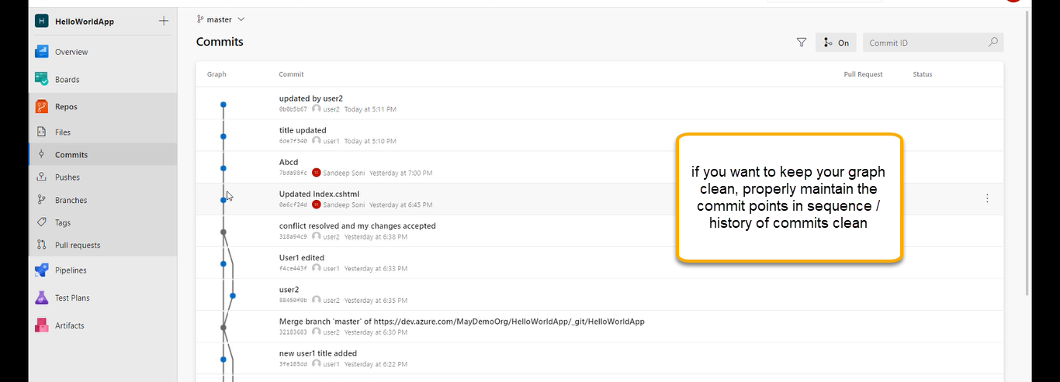

Azure Cherry Pick

If you are taking the changes from others. One specific commit I need to merge to branch not all the changes I need. This commit highlighted in black I need to apply to branch ( highlighted)



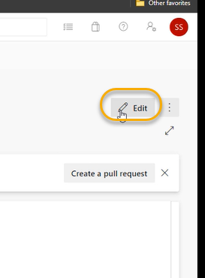

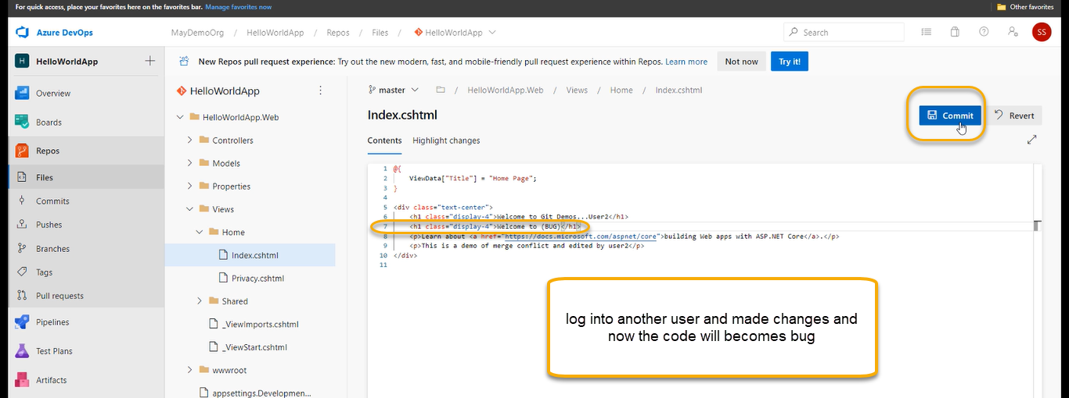

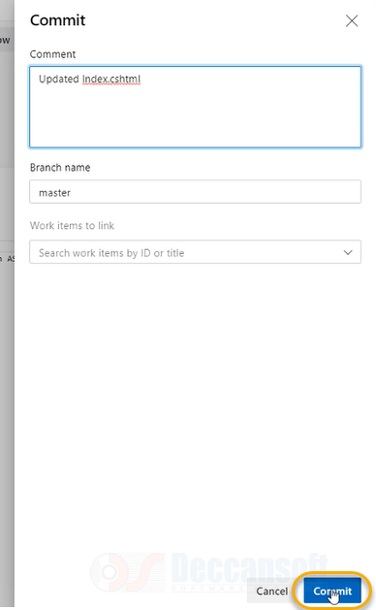

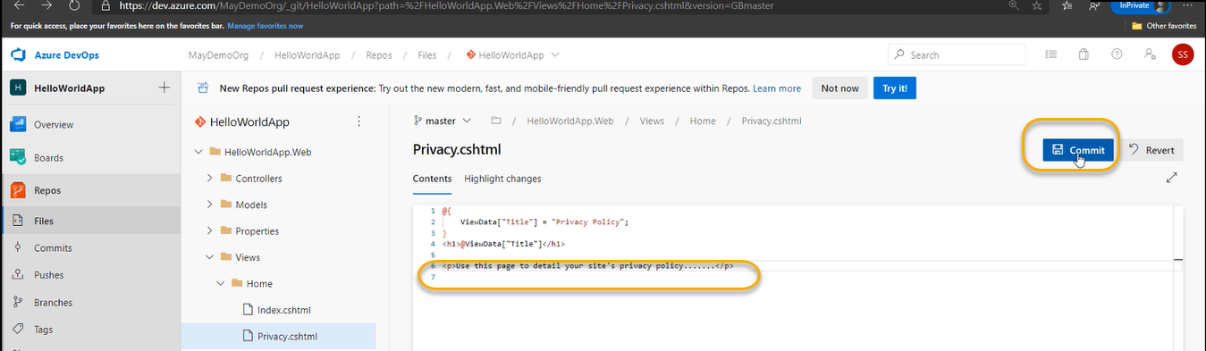

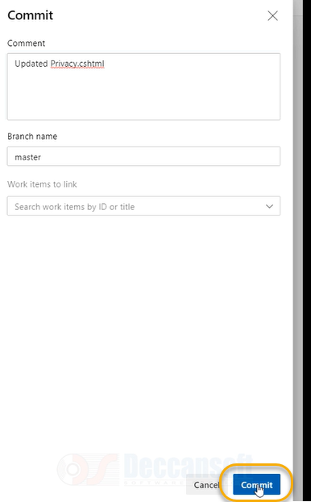

Now the poor developer does not know there are bug in the code and he will pull that code

git pull origin master

user1 made a bug and user 2 pull the code

code .

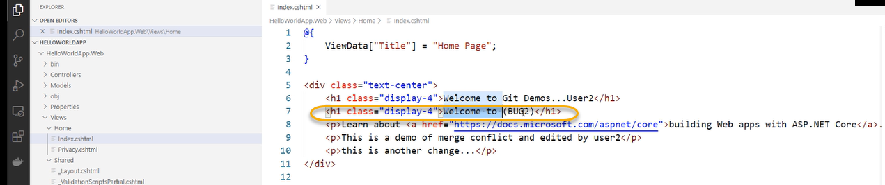

And user 2 made changes to the code

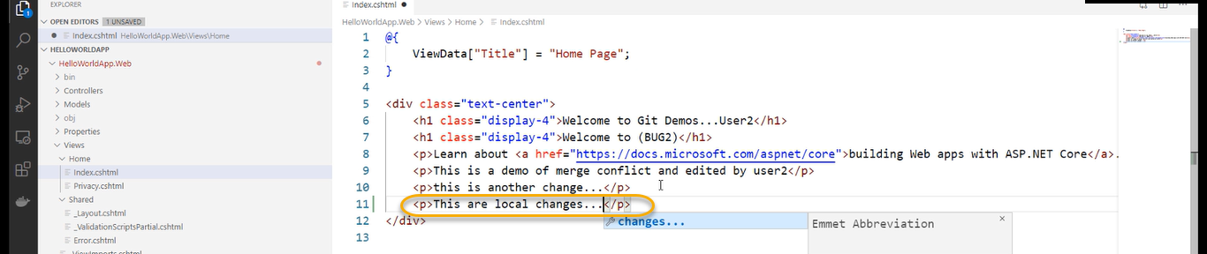

git add .

git commit -m “ new line added”

To test the build whether it is passed or not run the below command

dotnet build

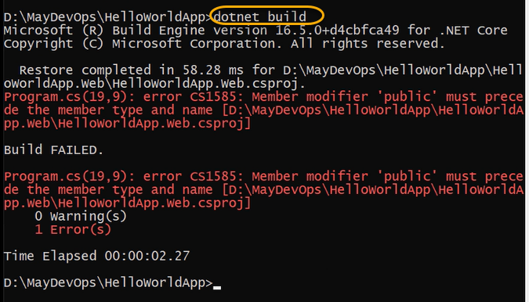

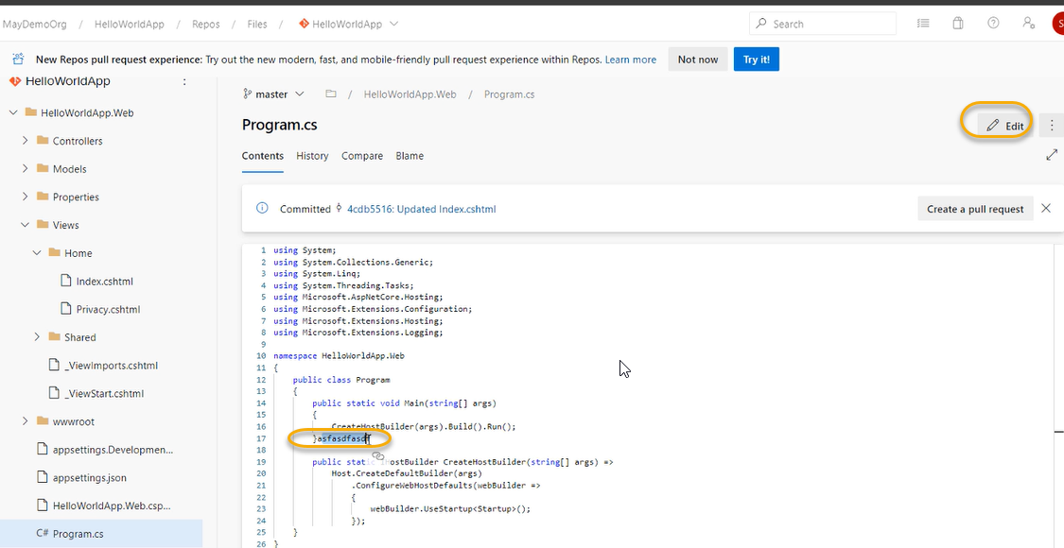

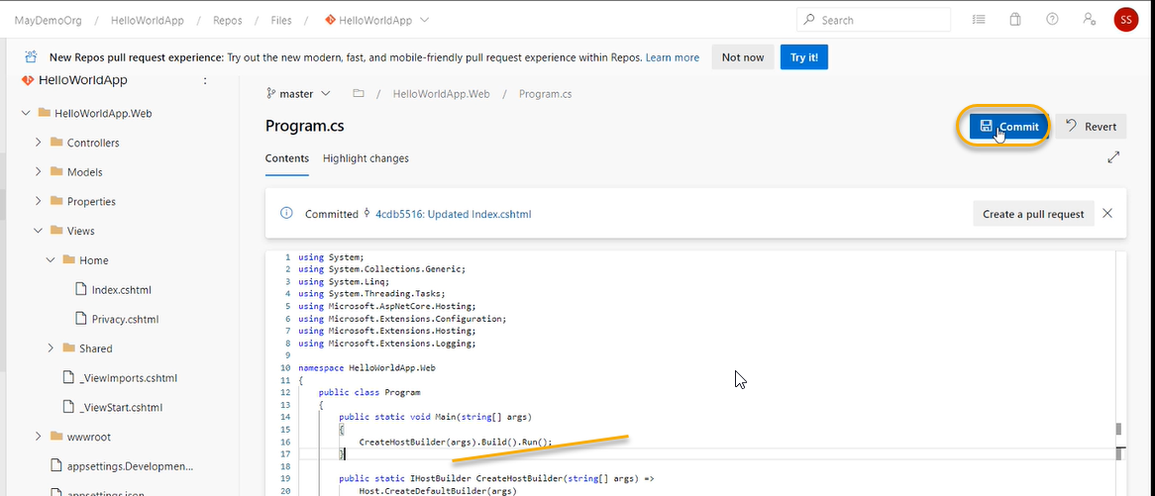

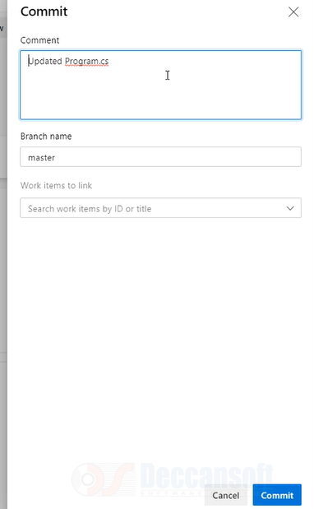

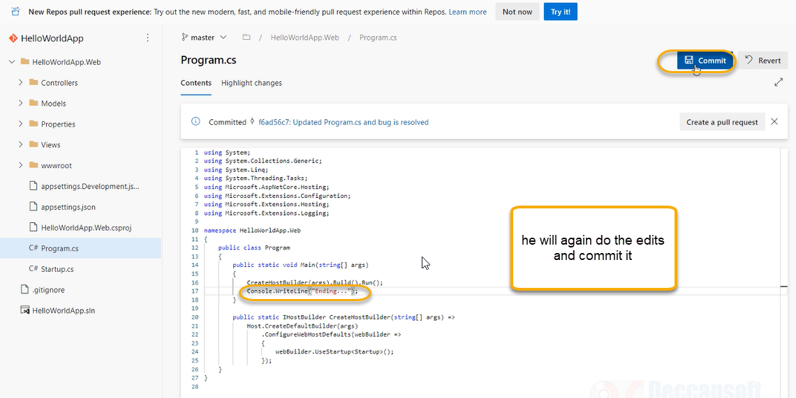

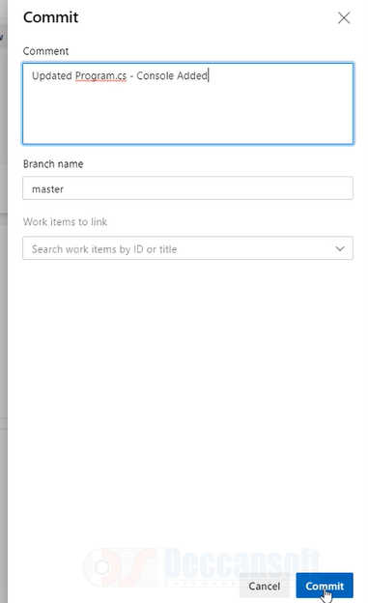

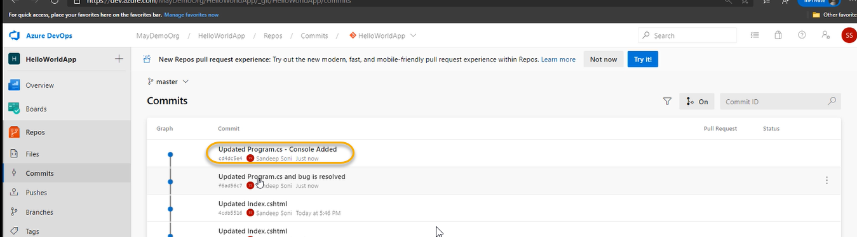

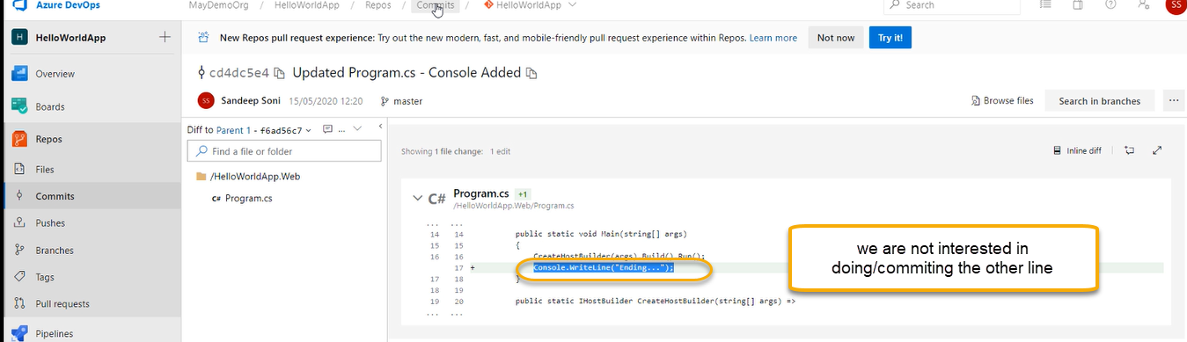

I want to terminate the console added commit and continue with code that is my requirement

And if you do git pull origin master all the changes will come which is NOT wanted

git remote add hotfix url

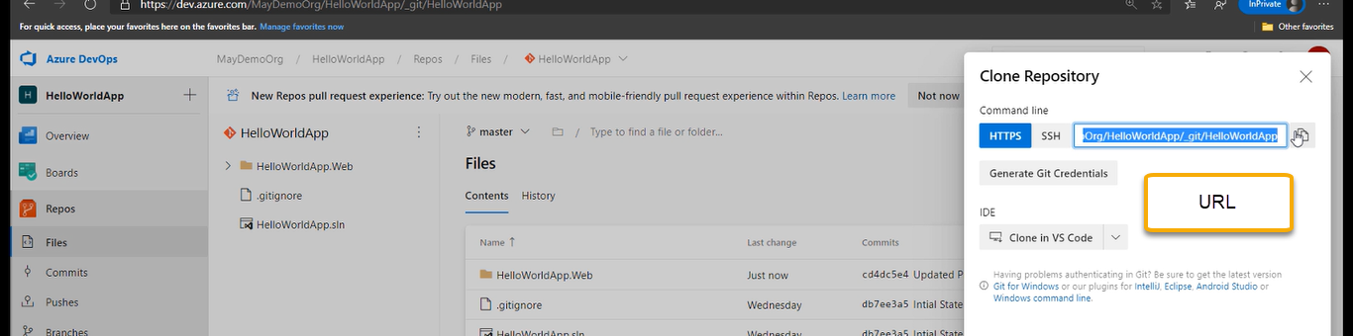



Now run git fetch hotfix

It will history of hotfix

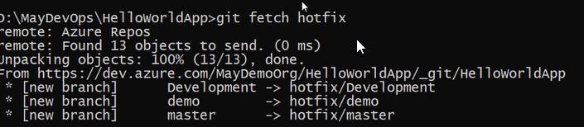

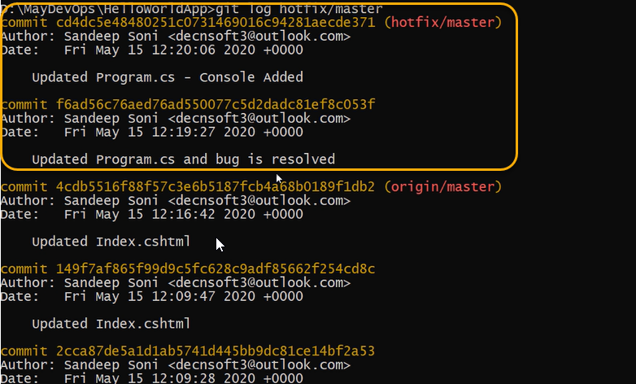

If run the git log we will not see this changes

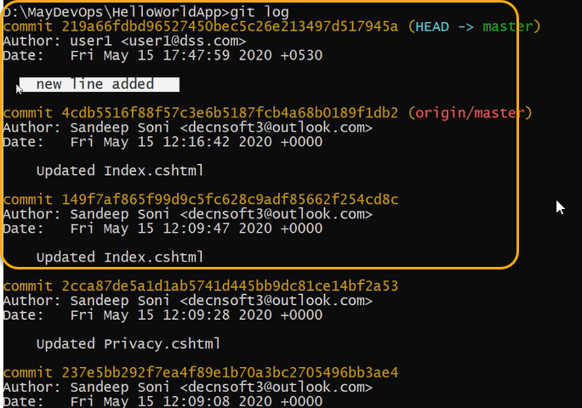

git cherry -pick SHAW1



Now run the dotnet build we will not see any error

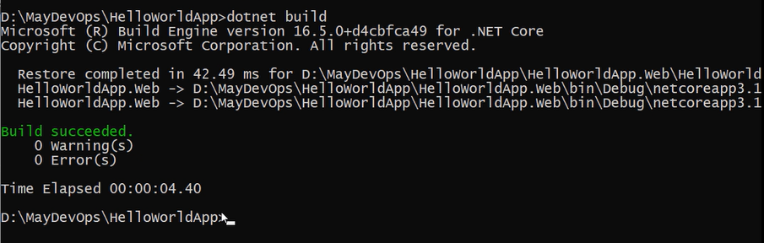

Run the code .

And we see that console added commit is not added in the code locally

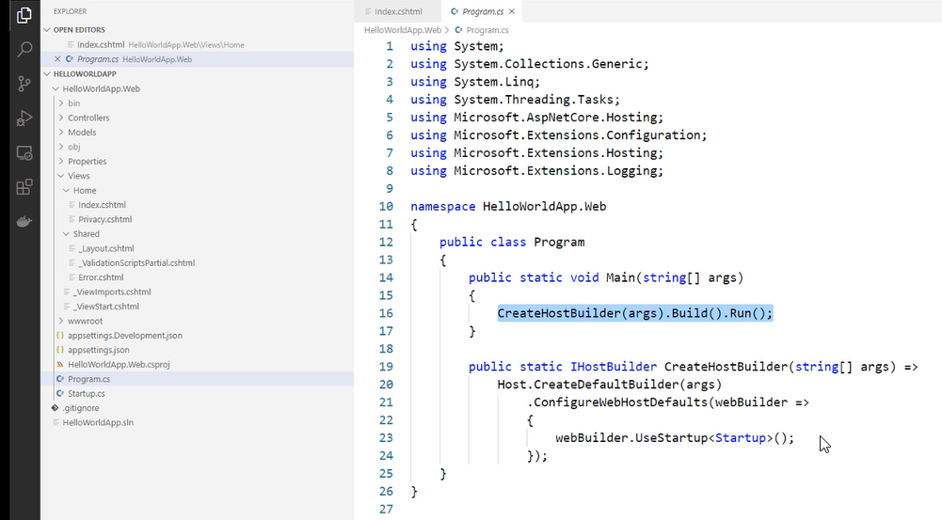

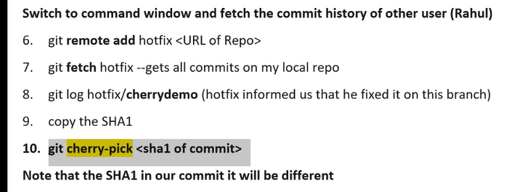

Undo changes using revert and reset

We have made commits up to last point we called it as head and after that we have staged and NOT committed, and we need to revert changes to head

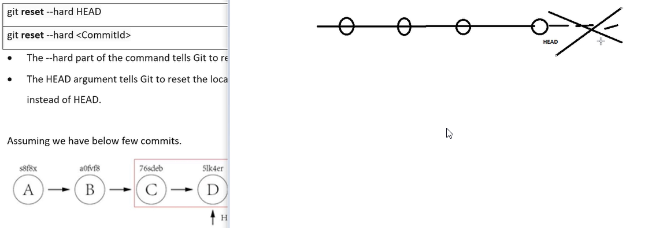

git reset – hard Head

git reset –hard <SHA Commit ID>

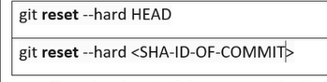

However, if we push the changes to remote repo then it will not update it

git push -f origin master (we need to push forcefully however it is a risky process)

because if previous commits are good, we cannot revert back it all changes are permanently lost.

git reset deletes the git history permanently and there is no way of coming back of previous commits

that is the reason we need to use the git revert

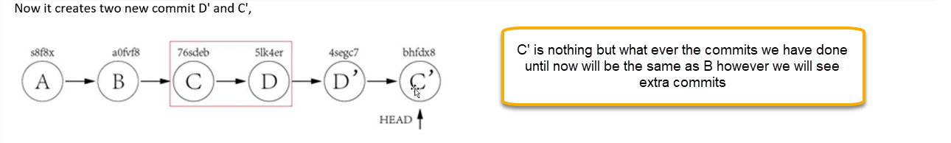

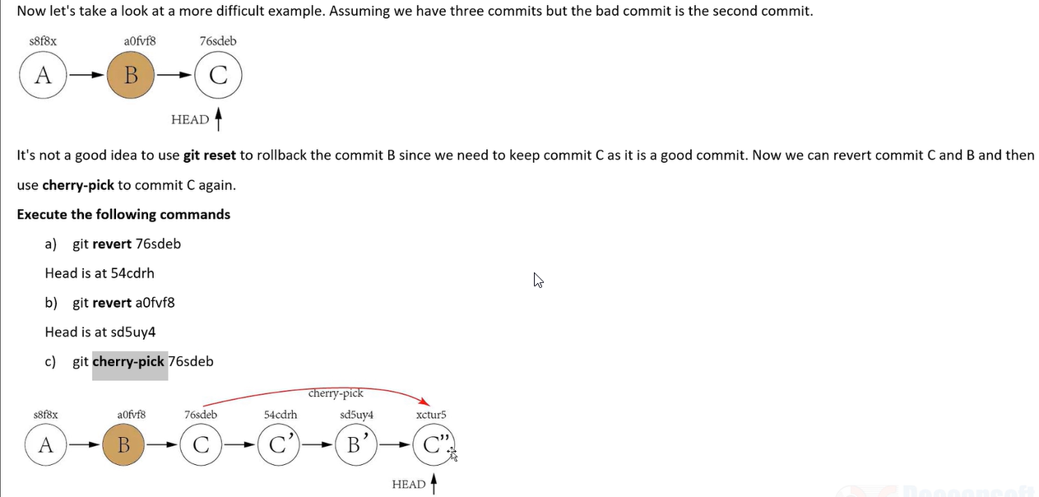

It is recommended to use git revert instead of git reset in enterprise environment.

Ignore files changes with Git

1. git ignore if you don’t want to stage and add certain files we can use .git ignore

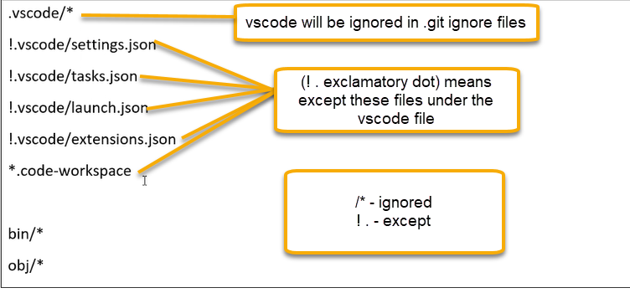

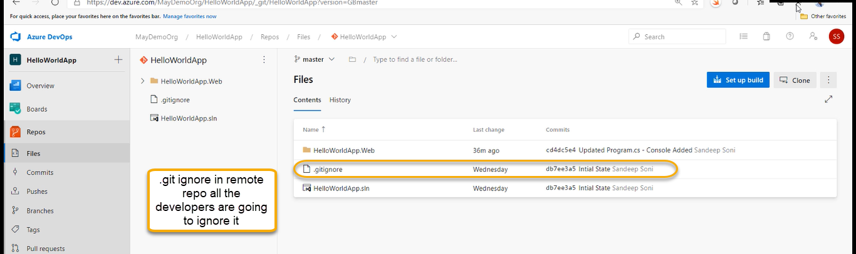



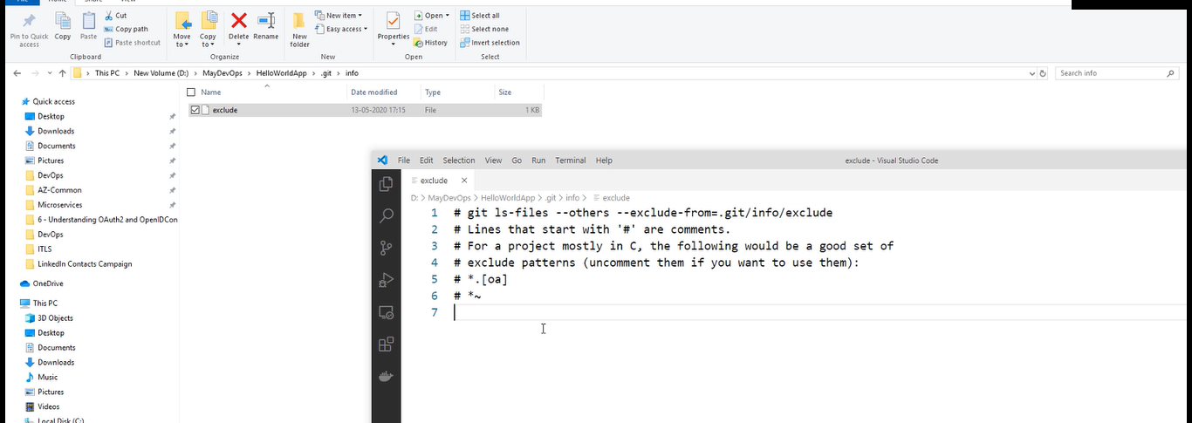

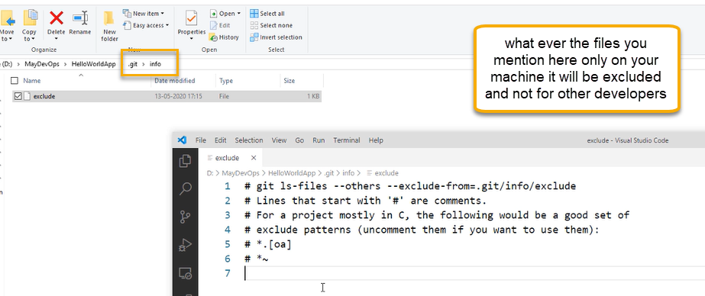

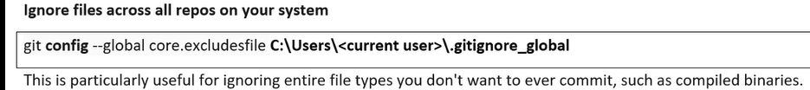

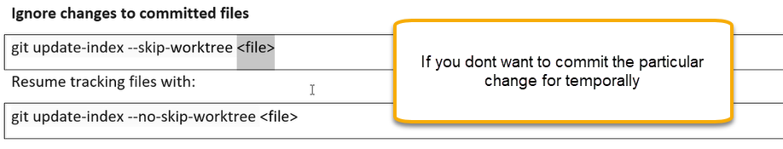

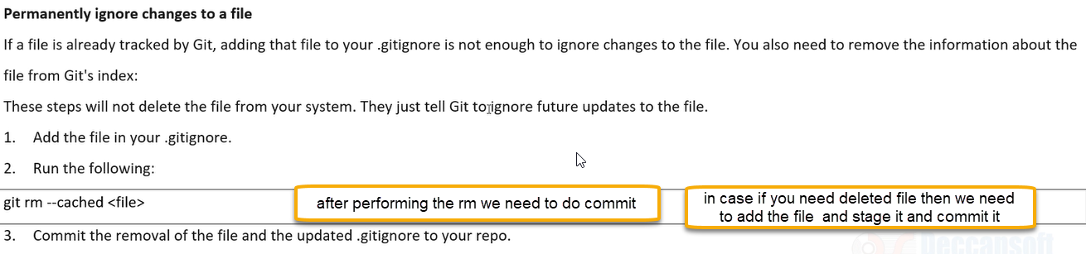

Git hub integration

Git Hib is similar to Azure repos however Git hub is most popular one and used from old ages

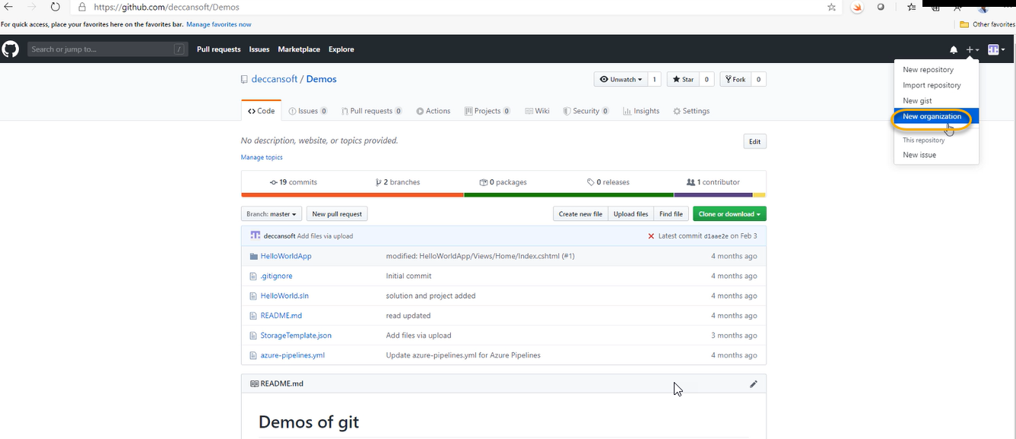

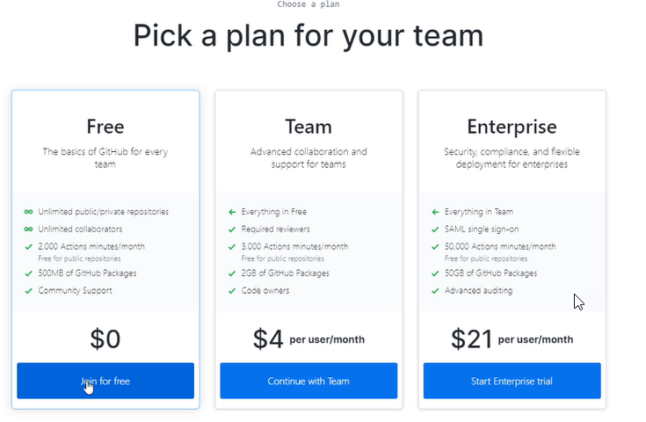

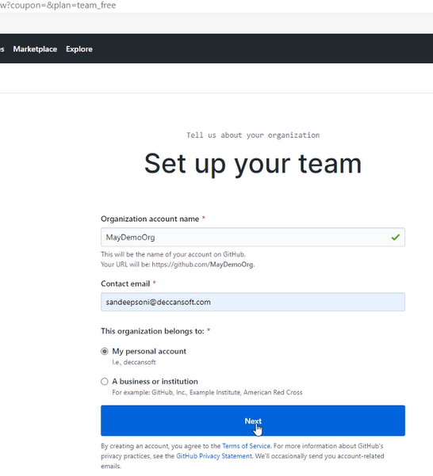

And gain complete the set up

Create the password

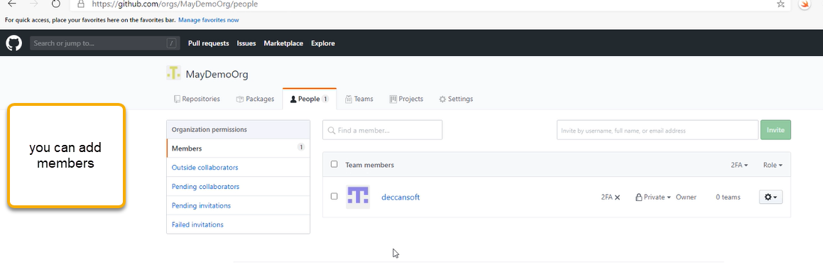

Now click on the Repositories

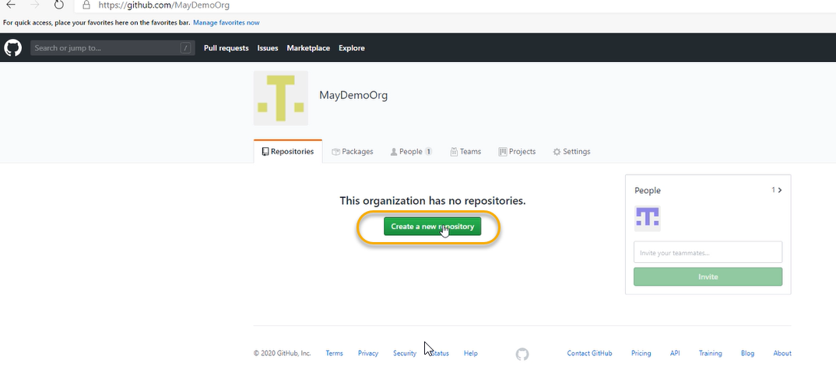

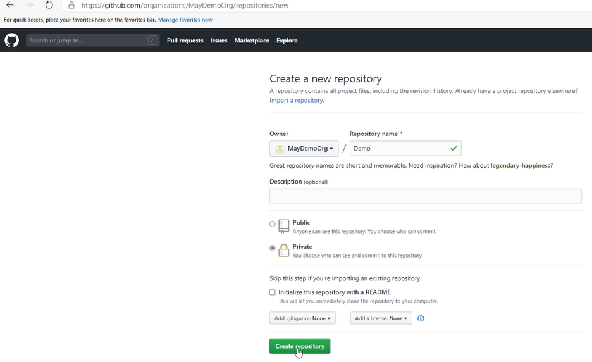

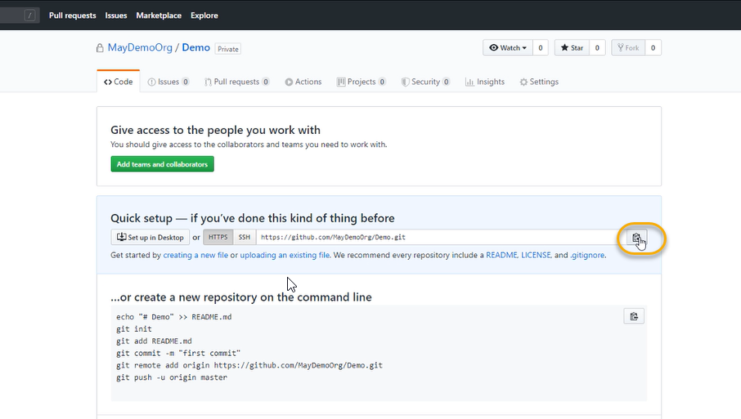

Copy the URL

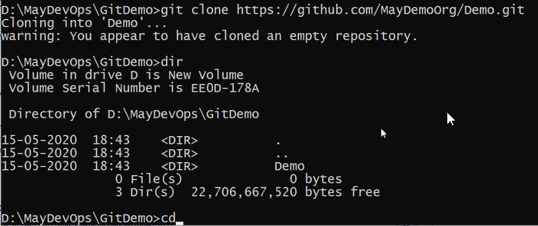

Because of the clone .git folder has came

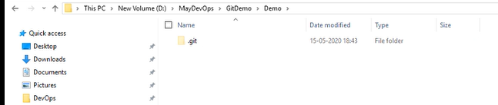

And now execute the dotnet new mvc

